Data Migration

* In the new world users data will reside in the cloud “One Drive”
  + P&G is going to provide guidelines on what data should be in the cloud. Ex Business related data should be in the cloud, however music should remain local.
* Each user will get 5TB One Drive folder
* All files/folder that reside under C:\Users\UserID\OneDrive – Procter and Gamble will be synced with cloud. This is OneDrive for Business

In-Place Upgrade O&G Machine

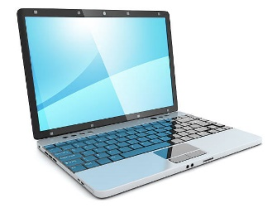

O&G Machine

* Install & Configure OneDrive
* OneDrive folder: C:\Users\UserID\OneDrive – Procter and Gamble
* Move User Data to OneDrive Folder

In-Place Upgrade Win10 Machine



O&G Machine

* Install & Configure OneDrive
* OneDrive folder: C:\Users\UserID\OneDrive – Procter and Gamble
* Sync user Data from OneDrive Folder
* When installation is completed the data migration is started

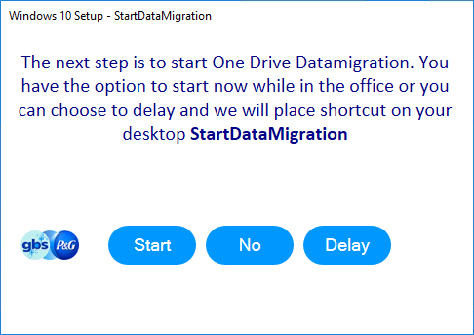You will have 3 options:

* Start Data Migration
  + This will start the OneDrive Migration and link

user account with One Drive for Business

* Delay Data Migration
  + Give user option to Start Data migration later time
* **No Data Migration** 🡺 **Select this option**
  + This will configure OneDrive and start syncing automatically

1. **Setup OneDrive Application**

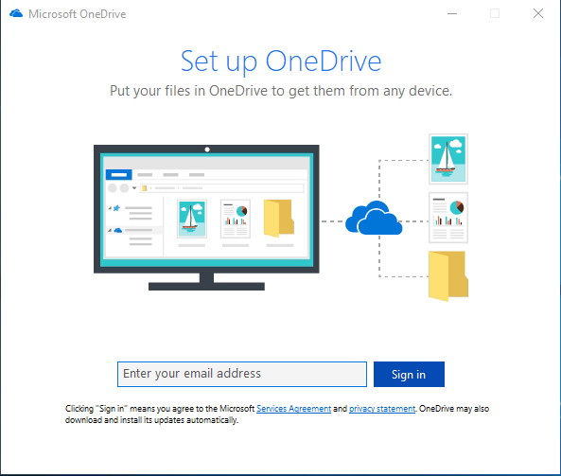

1. Setup OneDrive Application
2. **PingID authentication**

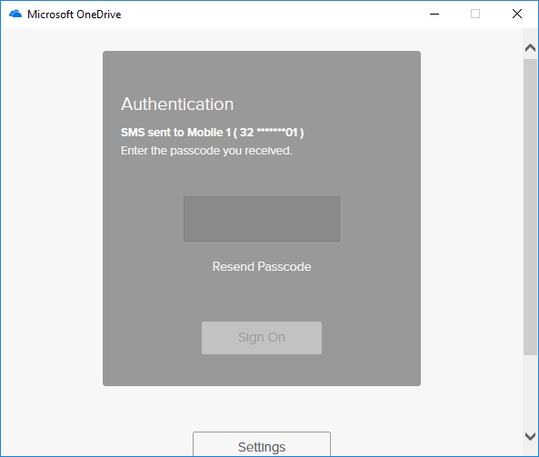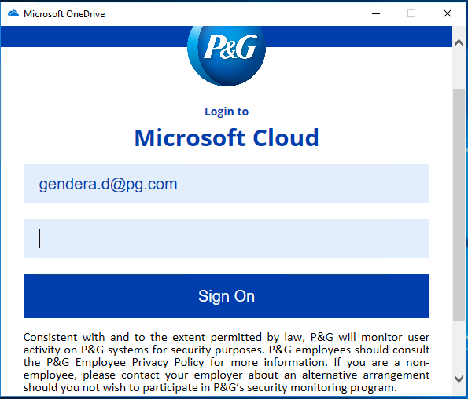

1. 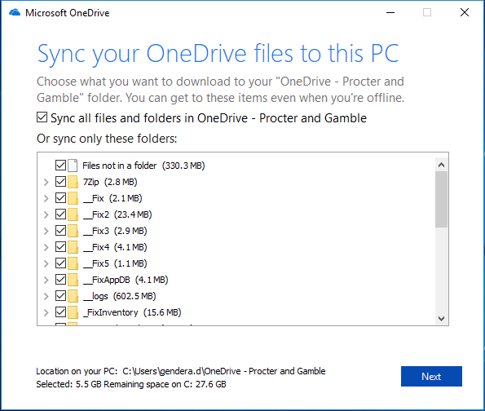Setup OneDrive Application
2. PingID authentication
3. **Configure OneDrive Folder**

C:\Users\<userid>\OneDrive – Procter and Gamble

1. 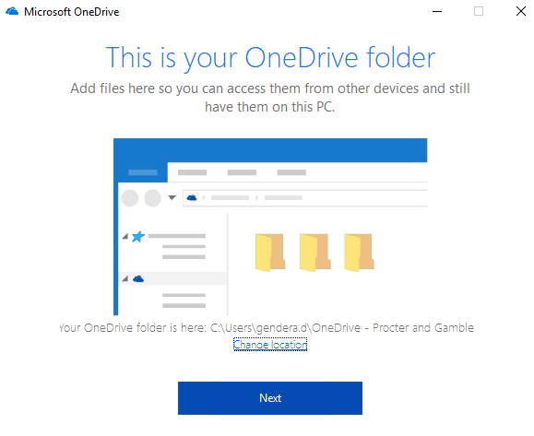Setup OneDrive Application
2. PingID authentication
3. Configure OneDrive Folder
4. **Select Folders to Sync**
5. 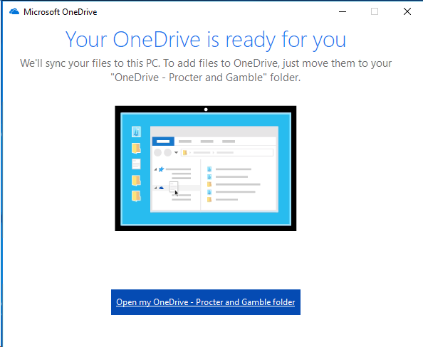Setup OneDrive Application
6. PingID authentication
7. Configure OneDrive Folder
8. Select Folders to Sync
9. **Close / Open OneDrive folder**
10. 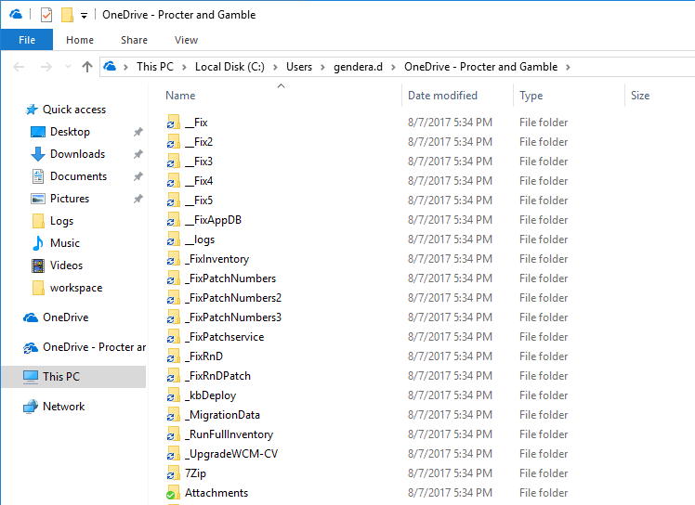Setup OneDrive Application
11. PingID authentication
12. Configure OneDrive Folder
13. Select Folders to Sync
14. Close / Open OneDrive folder
15. **Sync will start automatically**
16. Setup OneDrive Application

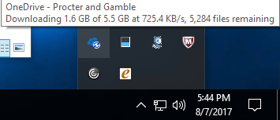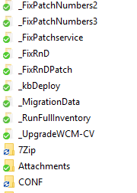

1. PingID authentication
2. Configure OneDrive Folder
3. Select Folders to Sync
4. Close / Open OneDrive folder
5. Sync will start automatically
6. **Track Sync (Optional)**
   1. **OneDrive – Task Manager**
   2. **Folder Sync**

Q&A

* Q&A
* Feedback
* Open discussion